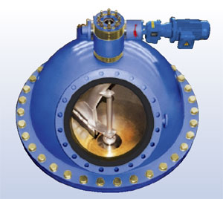
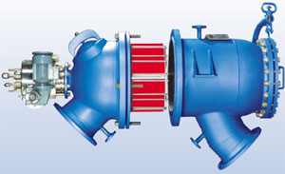
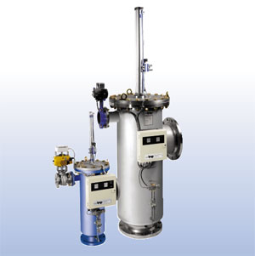
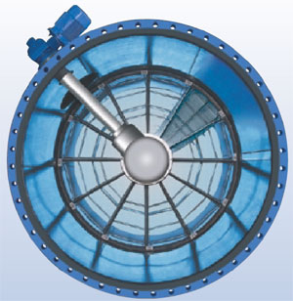

QUESTIONNAIRE

TAPROGGE 

Automatic
High-Performance
Backwash Filter

① Project Details and Contact
1 | Operator
2 | Power Station |  |  |  |  |  |  |  |  |  |  |  |  | Turbine no. |  |  |  | MW
3 | Type |  |  | Nuclear |  | Hydro |  |  |  | Thermal |  | CCPP |  | Year of Construction
4  please tick ☒ relevant field | Person in charge |  |  |  |  |  |  |  |  |  |  |  | Title/function
5 | Phone |  |  |  |  |  | Fax |  |  |  |  |  | E-mail

② Basic Data required for Proposal
6 | Project / Ref. no.
7 | Number of Filters
8 | TAPROGGE Reference
9 | Type of cooling water |  | sea |  |  | river |  |  | brackish |  |  |  | CT |  |  | well
10 | CW Flow rate | min. |  |  |  |  | normal |  |  |  | max. |  |  |  |  |  | kg/s / m³/h
11 | Pipe connection – nominal diameter |  |  | inlet DN |  |  |  |  |  |  | outlet DN
12 | Operating / design pressure |  |  |  |  |  |  |  |  |  |  |  |  |  |  |  |  | bar
13 | Operating / design temperature |  |  |  |  |  |  |  |  |  |  |  |  |  |  |  |  | °C
14 | Required filter perforation |  |  |  |  |  |  |  |  |  |  |  |  |  |  |  |  | mm

③ Additional Data
15 | Type of cw prescreening |  | travelling band screens |  |  |  |  | coarse screens |  |  |  | fine screens |  |  |  | skip rakes
15 | Type of cw prescreening |  | other:
16 | Chemical treatment of CW? |  | chlorination |  |  | ferrous sulfate |  |  |  | phosphate |  |  |  | acids
17 | Type of debris |  | sand |  |  | silt |  |  |  | mussels |  |  |  | concrete
18 | Type of debris |  | plastic |  |  | wood |  |  |  | fibres |  |  |  | algae
18 | Max. particle size |  |  |  |  |  |  |  |  |  |  |  |  |  |  |  | mm

④ Filter Design
please tick ☒ relevant field
19 | Design code |  | ASME |  | AD-Merkbl. |  |  |  |  |  | others |  |  |  |  |  |  |  |  |  |  |  |  | Flanges
20 | TAPROGGE Standard accepted? |  |  |  |  |  | Δp System |  |  |  |  |  |  |  | Yes |  |  |  |  |  |  | No |  |  | Actuators |  |  |  | Yes |  |  |  | No
21 |  |  |  |  |  |  | Discharge flap |  |  |  |  |  |  |  |  |  | Yes |  |  |  |  |  | No
22 | Location of filter |  |  |  |  |  | indoors |  |  |  |  | outdoors
23 | Location of control panel |  |  |  |  |  | indoors |  |  |  |  | outdoors
24 | Voltage / type of enclosure |  |  |  |  |  |  |  |  |  |  |  |  | V |  |  |  |  |  |  |  |  |  |  |  | Ex proof
25 | Plant drawings submitted? |  |  |  |  |  | Yes |  |  | No |  |  |  | Water analysis submitted? |  |  |  |  |  |  |  |  |  |  |  |  | Yes |  |  |  | No
26 | Specification available? |  |  |  |  |  | Yes |  |  | No |  |  |  | Delivery date required
27 | Condenser tube cleaning system installed? |  |  |  |  |  |  |  |  |  |  |  |  | Yes |  |  |  |  |  |  | No |  |  | Head loss of condenser

filled up by: | place, date:

Remarks:

